The primary focus of Sprint 3 was to implement a multi-layered authentication system, outline a testing strategy, and conduct automated and manual testing across the TigerTix microservices. This report summarizes the intended behavior of the authentication workflows, the rationale behind security decisions, the structure of our testing, and how the system is expected to operate.
The authentication system for this sprint introduced secure session registration, login, token-based session handling, and access control for protected routes. Rather than using plain text, passwords are stored using a hashing mechanism. This is a standard security practice, designed to protect user information even if the database is compromised. The way hashing works is that it prevents passwords from being reversed back to their original forms. Salting works by preventing attackers from using precomputed rainbow tables. We implemented JSON Web Tokens or JWTs for user authentication because they support a stateless architecture, which is beneficial to a microservices environment. By using JWTs, each service can verify a user’s identity without relying on shared in-memory sessions, and the inclusion of token expiration helps mitigate long-term exposure if a token is stolen. Despite these measures significantly improving security, potential vulnerabilities still exist. Examples include the lack of rate limiting for login or the lack of multi-factor authentication.
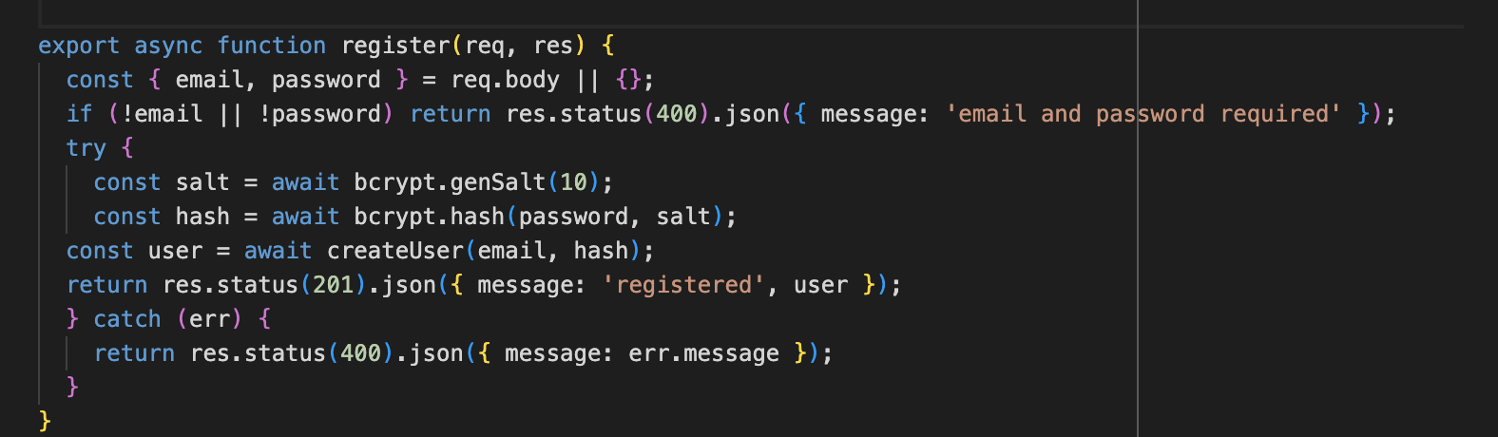
This image shows how the password is salted and hashed before storing it, preventing plain-text storage.
Our testing strategy for Sprint 3 includes unit testing, integration testing, and end-to-end manual testing. Unit testing focuses on individual functions, specifically in the user model. Tests like this enable us to isolate small pieces of functionality and verify their correctness without involving external components. Integration testing is used to verify that the authentication microservice functions properly with other components of the system. This includes validating registration and login behavior, ensuring JWT cookies are issued and read correctly, verifying access to protected routes, and checking that the Admin and Client services function as expected. These integration tests help confirm that the system’s microservices communicate and share data consistently. End-to-end testing involves evaluating how the entire system behaves from the user’s perspective. This includes tests for natural-language booking with the LLM, voice interactions, keyboard-only navigation, screen reader accessibility, and concurrent ticket purchases. These tests are done manually as they require a realistic human approach and timing.
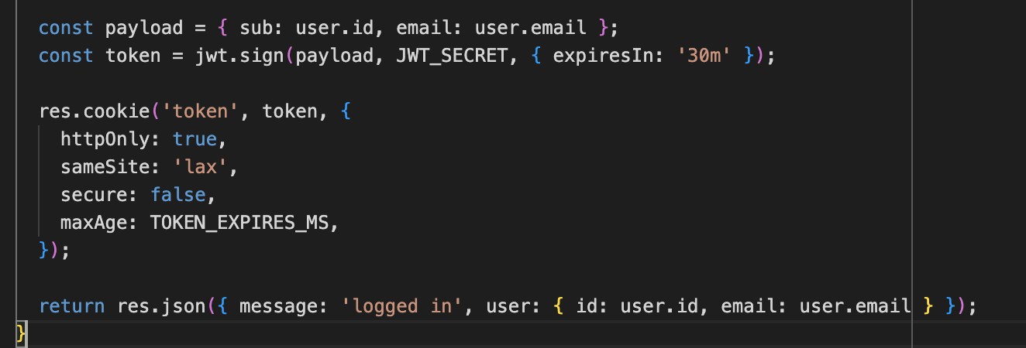
This is where the server issues a signed JWT and stores it in an HTTP-only cookie so the client cannot access it directly.
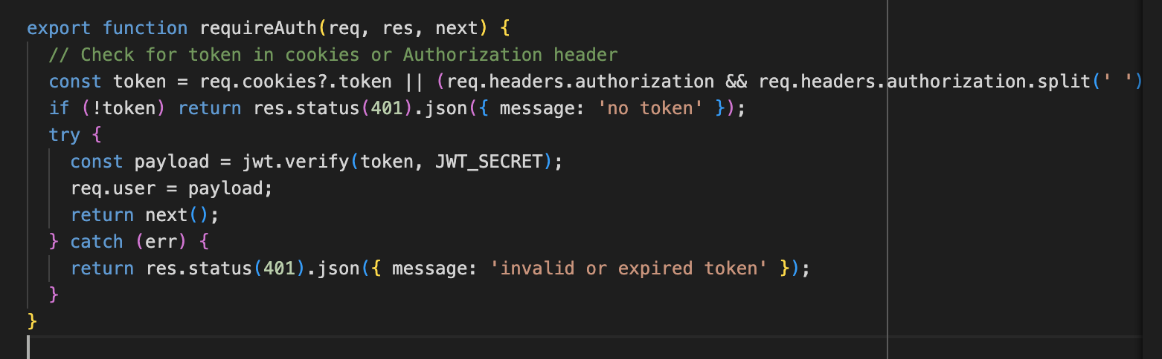
This middleware ensures only authenticated users can access protected endpoints such as ticket purchases.
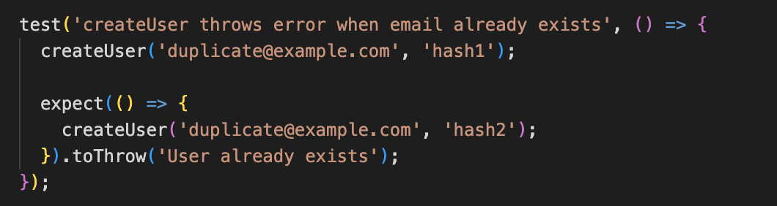
This verifies the user model correctly enforces unique accounts.
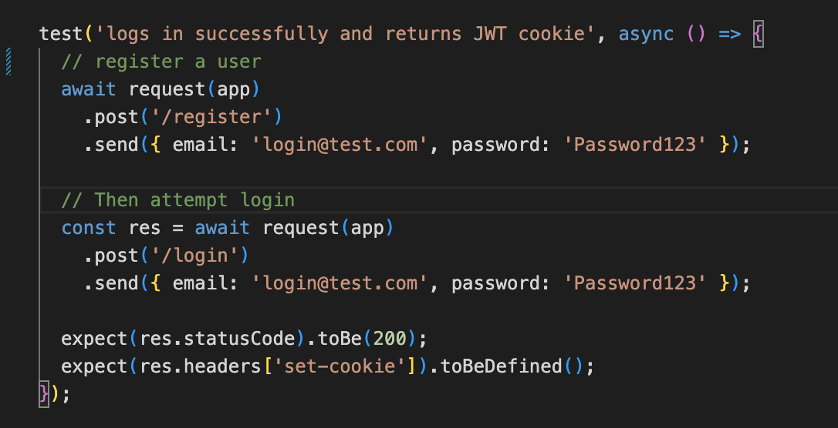
This integration test checks that login works end-to-end and sets a valid session cookie.
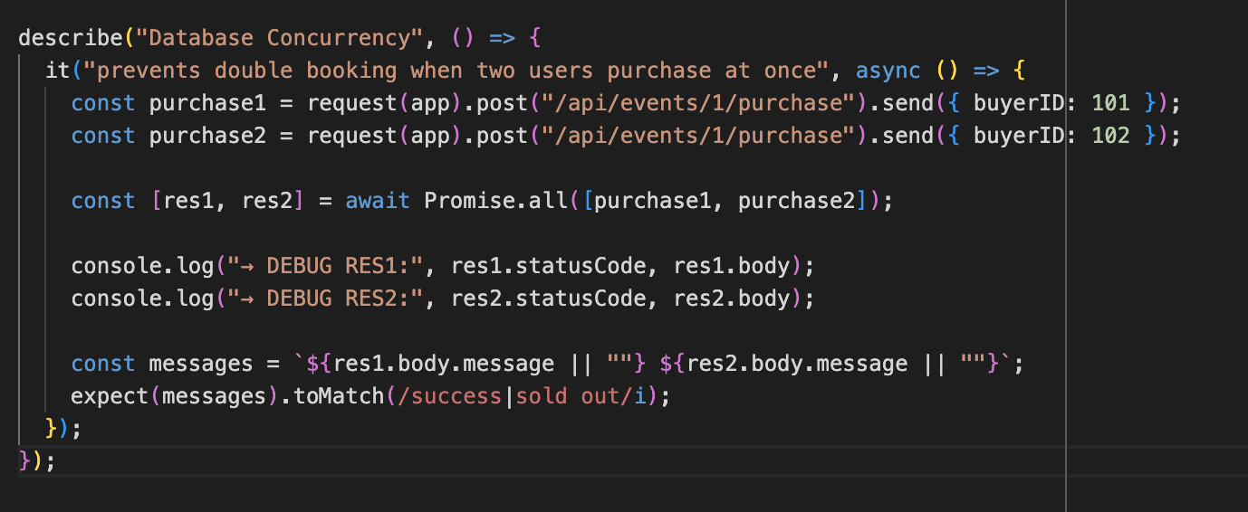
This test sends two purchase requests at the same time and verifies that SQLite’s transactional logic prevents both users from buying the final ticket, ensuring that only one purchase succeeds while the other correctly returns “sold out.”
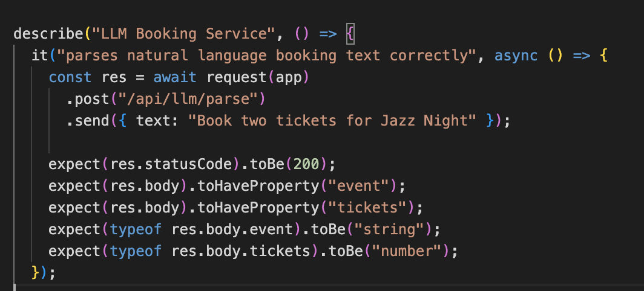
This checks that the LLM understands the user’s message and extracts the right event and ticket amount.
Once manual testing is performed, we expect to evaluate several critical behaviors throughout the system. For the natural language booking workflow, we plan to simulate users entering conversational prompts and verify that the LLM correctly interprets event details and requests confirmation before making a booking. Voice interaction testing will involve speaking aloud and issuing commands, observing how the system transcribes speech, reads back the interpreted request, and requires confirmation before proceeding. Accessibility testing will check whether users can navigate the interface using only a keyboard and whether a screen reader can correctly announce form fields, buttons, and navigation landmarks. Concurrent booking behavior will be assessed by attempting to have two users purchase the last available ticket simultaneously. The expected result is that only one transaction should succeed while the other is blocked. Authentication edge-case testing will include attempting to log in with incorrect credentials, accessing protected routes without a token, observing the behavior of expired tokens, and verifying that logging out clears the user’s session.
The automated portion of our testing involved running the test files that had already been prepared for the project. These include authentication tests that simulate registration, login, incorrect password attempts, protected route checks, and logout functionality; user model tests that validate user creation, duplicate account handling, and user lookup behavior, as well as tests for both the Admin and Client services that confirm events can be created, validated, listed, and purchased correctly. These automated tests are designed to serve as regression tests, ensuring that changes introduced in future sprints do not unintentionally break existing features.
Accessibility Considerations
For this sprint, we ensured that key features of the interface are accessible to visually impaired users. Elements such as form fields, buttons, and navigation controls include descriptive ARIA-labels, which allow screen readers to correctly announce their purpose. We also made sure that all interactive elements are usable using keyboard-only navigation. Structured headings and clearly marked sections help screen readers understand how the page is organized. These accessibility choices ensure that core functions like logging in, registering, and confirming LLM booking requests remain usable for all users.
Overall, Sprint 3 establishes the foundation for secure authentication and reliable communications across the TigerTix system. The authentication microservice now includes core features needed to protect user identities This sprint also included the execution of our planned testing strategy: unit tests were used to verify core logic within the user model, integration tests confirmed end-to-end interactions among the Admin, Client, and Authentication services, and manual tests explored real user workflows such as natural-language booking, voice interaction, accessibility navigation, and concurrent ticket behavior. Together, these tests allowed us to assess the correctness, reliability, and usability of the system. In the next sprint, we will incorporate more detailed test evidence, address any issues identified during this round of testing, strengthen overall security, and continue refining the architecture and user experience as the system grows in complexity.

Manual Testing Case | Expected Behavior | Actual Result
Voice Booking | Speech transcribed accurately and confirmed before booking | Worked as expected
Accessibility Navigation | Screen reader announces elements; keyboard navigation works | Worked as expected
Concurrent Purchase | Only one of two simultaneous purchases succeeds | Worked as expected
Authentication Edge Cases | Wrong passwords rejected; expired tokens invalid | Worked as expected
Natural Language Booking | LLM interprets the request and asks for confirmation | Worked as expected

